

**Training Guide for ClO2 Chemical Plant**

Contents

1. Introduction 3

1.1 Welcome 3

1.2 Safety Precautions 3

1.3 Running a Unity Executable on Windows 3

1.4 Troubleshooting Common Issues 3

2. Setup and Navigation 5

2.1 Preparing for VR Mode 5

2.2 Navigating in VR Mode 5

2.3 Navigating in Keyboard and Mouse mode 6

2.4 Navigation Visual Guide 8

3. Exploration 10

4. Plant Environment 11

4.1 Safety Equipment and Registration 11

4.2 Key Components 11

4.3 Summarized Process Description 12

4.4 Emergency Scenarios 12

5. Conclusion 12

6. Appendix: First-Time HTC Vive Setup 13

6.1 Unbox and Prepare Your HTC Vive 13

6.2 Set Up the Base Stations 13

6.3 Connect the Link Box 13

6.4 Install Steam and SteamVR 13

6.5 Configure SteamVR 13

6.6 Pair the Controllers 13

6.7 Final Adjustments 14

6.8 Test and Play 14

6.9 Additional Tips 14

7. Appendix: Computer Requirements 14

7.1 Minimum Requirements: 14

7.2 Recommended Requirements: 15

1. **Introduction**
   1. **Welcome**

Welcome to the Virtual Reality Chlorine Dioxide plant! This VR activity will help you become more familiar with the processes and elements of a real mining engineering plant.

* 1. **Safety Precautions**

When interacting in a VR environment, it is important to be aware of your physical surroundings (especially when using the VR headset). Avoid making any quick and sudden movements, as you may collide with real-life objects. If you experience any discomfort or motion sickness, exit the VR simulation and report your symptoms to your instructor.

* 1. **Running a Unity Executable on Windows**
* Find the folder where your Unity project was built. This folder will typically contain the executable file (.exe) and a subfolder with the same name as the executable file, which contains additional data required by the executable.
* Make sure the following are in the same directory:
  + The executable file (i.e. ChemicalPlant.exe)
  + The ChemicalPlant Data folder
  + UnityPlayer.dll
* Double-click the executable file (ChemicalPlant.exe). This will start the application.

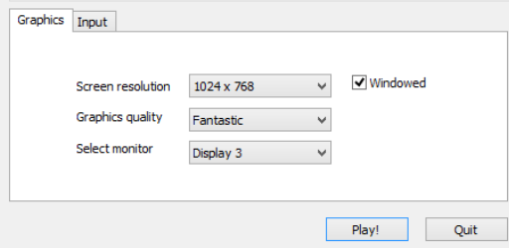

When you run the executable for the first time, you might be prompted with a configuration window where you can set the screen resolution, graphics quality, and input settings. Adjust these settings as needed and click "Play" or "OK" to start the application.

* 1. **Troubleshooting Common Issues**
* **Missing Files Error**: Ensure that the ChemicalPlant_Data folder is in the same directory as the executable. (Always keep the executable and its associated data folder together when moving or copying the project to avoid missing file errors. Copying-and-pasting the .exe file to a directory without bringing its required components will render it unusable)
* **Graphics or Performance Issues**: Adjust the graphics quality settings in the configuration window to a lower setting to improve performance.
* **Input Issues**: Ensure that your keyboard, mouse, or VR controllers are properly connected and configured.

1. **Setup and Navigation**
   1. **Preparing for VR Mode**

Before you begin, please ensure that you are properly wearing the VR headset and holding the controllers.

The HTC vive headset can be adjusted with a knob on the back of the headset, as well as a knob on the bottom right of the visor, which will calibrate the focus of the lens. Adjust both to minimize the level of blurriness.

If the HTC Vive hasn’t been previously set-up, visit this link or see **Section 6: First-time HTC Vive Setup**

* 1. **Navigating in VR Mode**

1. Navigate the environment by moving around and turning your head with the headset.’
2. Use the controllers to move within the environment by aiming at a location through the projection line by holding down the Trackpad button (see Figure 1), and release the button to teleport there.
3. Select and answer questions on the virtual board, and interact with objects and machinery using the Trigger button

**Going through a Door in VR Mode**

* Aim the Teleport Pointer:
  + Use your VR controller to point at the ground on the other side of the door. Typically, this is done by pressing and holding a button on your controller that activates the teleport function. A visible pointer or arc should appear.
* Position the Teleport Target:
  + Move the teleport pointer to position it on the ground past the door. Ensure the pointer is accurately placed where you want to teleport.
* Release the Button:
  + Once the teleport target is positioned correctly on the other side of the door, release the button. Your character should instantly move to the target location.
  + If the character does not teleport or the teleportation circle turns red, try a different angle.-

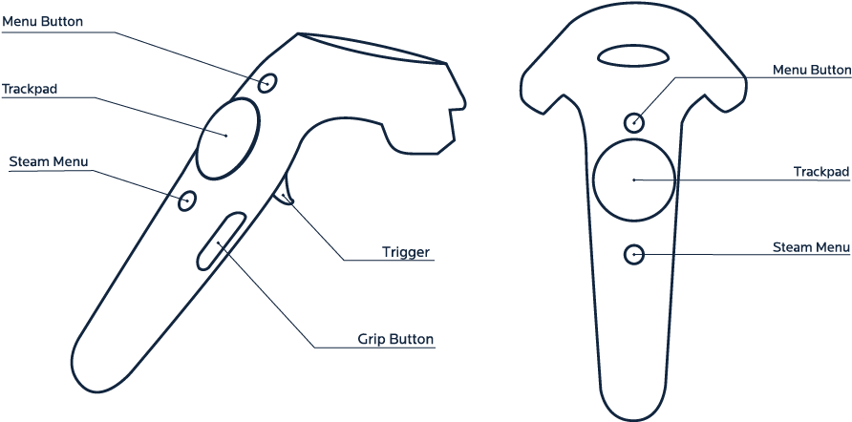

**Figure 1**: HTC Vive Controller Diagram: only Trackpad and Trigger are necessary for this activity

* 1. **Navigating in Keyboard and Mouse mode**

Use the WASD keys or arrow keys for movement.

Use the mouse to click on objects, answer questions, and interact.

**Key Functions**

* W / Up Arrow: Move forward
* A / Left Arrow: Move left
* S / Down Arrow: Move backward
* D / Right Arrow: Move right
* Esc: Close the Simulator

**Combining Movements**

* Diagonal Movement: Press two keys together (e.g., W + A or Up Arrow + Left Arrow to move forward and left).

**Stair Climbing**

* **Mouse (Look):** Move your mouse to look around and ensure your character is facing the stairs. You need to look in the direction you want to move. The crosshair shows where the user is looking.
* **Approach the Stairs:** Walk up to the base of the stairs by pressing the W key. Make sure your character is facing the stairs.
* **Walk Up the Stairs:** Continue to press and hold the W key to walk up the stairs. Your character should automatically step up each stair.
* **Jump if Stuck:** If your character gets stuck on the stairs, press the Space bar while holding the W key to make your character jump forward. This can help you get over any obstacles or difficult steps.

**Soft Barriers**

* **Definition:** Soft barriers are objects in the game world that do not have colliders attached to them. This means that they do not physically interact with the player or other objects in the game.
* **In this experience, doors are soft barriers, so the user can walk through them freely.**

**Hard Barriers**

* **Definition:** Hard barriers are objects in the game world that have colliders attached to them. Colliders are components that define the physical boundaries of an object, allowing it to interact with other objects and the player.
* In this experience, walls, railings, and machinery are hard barriers, so the user can not walk through them.
* If you’re too close to a hard barrier, hold S to walk backwards.

**Walking through a Door**

There’s no need for any special interaction or action to pass through a soft barrier, such as a door. Just move forward as you would through an open space. Here’s a step-by-step summary:

* W Key (Forward): Press and hold to move towards the door.
* A/D Keys (Left/Right): Adjust your position if necessary.
* Mouse (Look): Face the door to ensure you're heading in the right direction.
* Continue Walking: Hold the W key to walk through the door.

Since the door doesn't have a collider, it won't physically block your character, allowing you to move right through it effortlessly.

* 1. **Navigation Visual Guide**

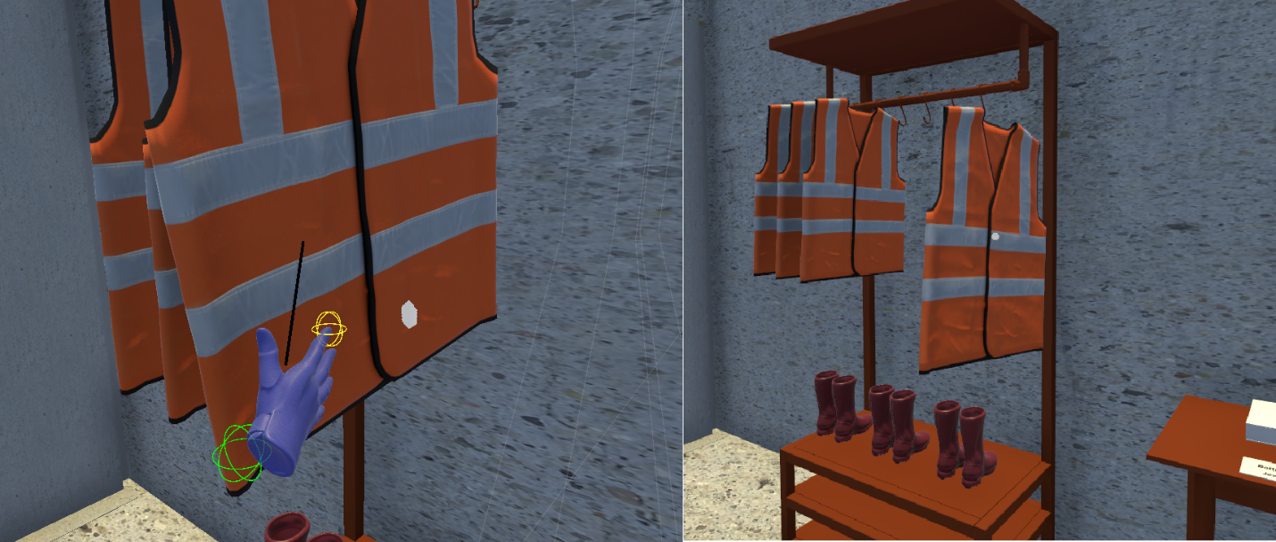

**Figure 2**: Using the VR hand or crosshair to pickup items

In VR mode, move the virtual hand close to the object and press the Trigger button to pick it up. In keyboard & mouse mode, hover the crosshair in the centre of the screen over the object and left click to pick it up.  Release the Trigger or left click to equip the object.

**Figure 3**: Using the VR controller or crosshair to select UI buttons

In VR mode, point the controller towards the UI buttons and press the Trigger button to select. In keyboard & mouse mode, hover the crosshair in the centre of the screen over the button to select it.

**Figure 4**: Circle showing teleportation location

A circle will appear on the floor when holding down the Trackpad button in VR mode. If the circle is green, release the button to teleport to this location, as shown in Figure 4.

1. **Exploration**

You may explore the chemical plant freely and at your own pace. There are 4 floors with equipment to explore, as well as an outdoor chemical storage area.

By the end of the exploration, you should be able to:

* List appropriate safety precautions, protective equipment, protocols, and practices specific to the chemical plant.
* Identify the main components of the plant and describe their functions.
* Identify the substance and direction of the flow of the pipes

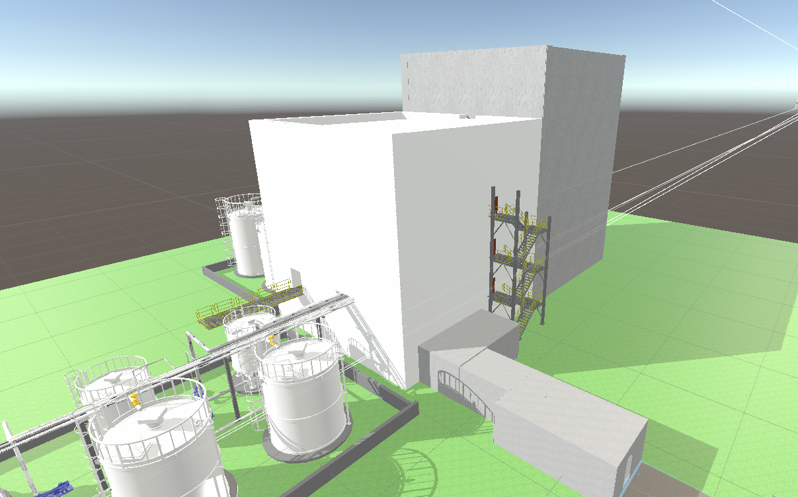

**Figure 5**: Exterior view of chemical plant

**Figure 5**: Top floor of chemical plant, user view

1. **Plant Environment**
   1. **Safety Equipment and Registration**

Enter the door into the registration room. It is common in plants to have visitors sign in and out so everyone is accounted for in the event of an emergency. After entering the door past the turnstile you will reach the safety equipment room. In this room, locate the:

* Safety Goggles
* Hard Hat
* Gas Mask
* Closed-Toed Boots
* Saefty Vest

Take note that in a real plant, long hair may need to be tied back and jewelry may need to be removed. If you are visiting a physical plant be sure to ask for specific safety information in advance.

* 1. **Key Components**

Leave the safety equipment room through the door and begin the guided tour. While navigating around the plant, take note of the following:

1. Red Chemical Alarms
2. Emergency Exits
3. First Aid/Safety Room

As you navigate the plant, locate the:

1. Ground Floor:
   * Vent Scrubber Seal Pot (TK-64)
   * Condensate Tank (TK-45)
   * Generator Reboiler (HE-44) *
   * Generator Loop (GL-43)
   * ClO2 Absorption Tower (TR-52) *
   * ClO2 Absorption Tower Seal Pot (TK-56)
2. First Floor:
   * Generator Dump Tank (GD-33)
   * Methanol Filters (FL-33)
   * Vent Scrubber (TR-61) *
   * Sulphuric Acid Filters (FL-23)
   * Generator Crystallizer (RX-41) *
   * Saltcake Mixing Tank (TK-74)
3. Second Floor:
   * Sodium Chlorate Filters (FL-13)
   * Indirect Contact Cooler (HE-51)
   * Barometric Condenser (HE-55)
4. Third Floor:
   * Sulphuric Acid Head Tank (TK-24)
   * Tail Gas Exhaust Fan (BL-63)
   * Sodium Chlorate Head Tank (TK-14)
   * Slurry Filter Vacuum Ejector (EJ-76)
   * Generator Vacuum Ejector (EJ-54)
   * Slurry Filter (FL-72)
   * Separator Tank (TK-73)
   * Emergency Water Tank (TK-49)

*spans multiple floors

* 1. **Summarized Process Description**
* **Production:** Chlorine dioxide is generated by reacting sodium chlorate, sulfuric acid, and methanol in an evaporator/crystallizer reactor, operating at low pressure and temperature.
* **Evaporation and Condensation**: The reactor's reboiler evaporates water from the mixture, and a condenser removes water vapor to maintain vacuum and enhance ClO2 absorption.
* **Absorption:** Chilled water in the ClO2 absorber absorbs most of the ClO2 gas, with remaining CO2 and minimal ClO2 exiting the system.
* **Storage:** The final ClO2 solution is stored in multiple tanks with internal floating roofs to reduce evaporation and ensure safety.
* **By-product Handling:** Sodium sesquisulphate crystals are filtered and recycled, and a scrubber captures stray ClO2 gases to ensure efficient operation and minimize chemical loss.
  1. **Emergency Scenarios**

In the event of an emergency, workers would exit through the emergency exit. Located near each emergency exit is a chemical shower, eyewash station, and first aid kit.

1. **Conclusion**

In this document, we explored the Virtual Reality (VR) Chlorine Dioxide plant, starting with an introduction to the plant and safety precautions for VR usage. We learned how to run a Unity executable on Windows and troubleshoot common issues. The guide provided detailed instructions for navigating the VR environment using both VR controllers and keyboard/mouse setups, including how to move through the plant and interact with objects. Finally, the document outlined the key components and areas within the plant to explore, as well as emergency procedures to follow in case of an incident. This comprehensive guide ensures users can safely and effectively engage with the VR Chlorine Dioxide plant simulation.

1. **Appendix: First-Time HTC Vive Setup**
   1. **Unbox and Prepare Your HTC Vive**

* **Unbox all components**: Ensure you have all parts, including the headset, link box, controllers, base stations, and necessary cables.
* **Charge the controllers**: Plug in the controllers using the provided USB cables and let them charge fully.
  1. **Set Up the Base Stations**
* **Placement**: Position the base stations diagonally across the room, about 6.5 feet (2 meters) high.
* **Mounting**: Use the provided mounts or tripods. Ensure they are angled downwards slightly to cover the play area.
* **Power**: Plug the base stations into power outlets and turn them on. The LEDs should turn from blue to green, indicating they are ready.
  1. **Connect the Link Box**
* **Connect the Headset**: Plug the HDMI and USB cables from the headset into the corresponding ports on the link box.
* **Power the Link Box**: Connect the link box to a power source using the provided adapter.
* **Connect to PC**: Use the remaining HDMI and USB cables to connect the link box to your PC.
  1. **Install Steam and SteamVR**
* **Download and Install Steam**: If you don’t have Steam installed, download it from Steam's website and install it on your PC.
* **Sign in to Steam**: Create an account or log in with your existing account.
* **Install SteamVR**: Search for SteamVR in the Steam store, download, and install it.
  1. **Configure SteamVR**
* **Launch SteamVR**: Open Steam and navigate to the Library. Find SteamVR and click "Launch."
* **Run Room Setup**: Follow the on-screen instructions to set up your play area. You can choose between a Standing Only or Room-Scale setup.
  + **Standing Only**: Suitable for smaller spaces, where you’ll mostly be standing or sitting in one spot.
  + **Room-Scale**: Requires a larger area where you can move around. Define the play area by tracing the boundaries with your controller.
  1. **Pair the Controllers**
* **Turn on the Controllers**: Press the system button on each controller until they turn on.
* **Pairing**: Follow the on-screen instructions in SteamVR to pair the controllers with the headset. The LEDs on the controllers should turn from blue to green.
  1. **Final Adjustments**
* **Adjust the Headset**: Put on the headset and adjust the straps for a comfortable fit. Use the interpupillary distance (IPD) knob to set the lenses to match your eyes.
* **Check the Display**: Make sure the headset display is clear. Adjust the position of the headset on your face if needed.
  1. **Test and Play**
* **Troubleshooting**: If you encounter any issues, refer to the SteamVR status window for guidance. Common fixes include re-running the room setup, ensuring all cables are securely connected, and checking that all devices are powered on and properly paired.
  1. **Additional Tips**
* **Play Area Safety**: Ensure your play area is free of obstacles to avoid tripping or knocking over objects.
* **Firmware Updates**: Regularly check for firmware updates for the headset, controllers, and base stations via SteamVR to ensure optimal performance.
* **VR Performance**: Ensure your PC meets the minimum requirements for VR. High-performance GPUs and CPUs are recommended for a smooth experience.

1. **Appendix: Computer Requirements**
   1. **Minimum Requirements:**
   2. Operating System:

* Windows 10 or later (64-bit)
* macOS 10.14 or later (64-bit)
* Linux (Ubuntu 18.04 or CentOS 7)
  1. Processor (CPU):
* Intel Core i5 or AMD equivalent
* For very simple games, an Intel Core i3 might suffice, but a Core i5 is safer to ensure smooth performance.
  1. Memory (RAM):
* 8 GB of RAM
* For simpler games, 4 GB might work, but 8 GB is a safer baseline for most Unity games.
  1. Graphics Card (GPU):
* Dedicated GPU with 2 GB of VRAM (e.g., NVIDIA GeForce GTX 660, AMD Radeon HD 7870)
* Integrated graphics like Intel HD Graphics 4000 may work for very simple or 2D games, but dedicated graphics are recommended for 3D games.
  1. Storage:
* At least 20 GB of free disk space for the game and assets.
* SSD is recommended for faster loading times, but an HDD will work for less demanding games.
  1. Display Resolution:
* 1280x720 minimum resolution
* Higher resolution is better for clarity, but this will depend on the game's graphical demands.
  1. **Recommended Requirements:**

For a more optimal experience, especially for more complex 3D games:

* 1. Processor (CPU):
* Intel Core i7 or AMD Ryzen 5
  1. Memory (RAM):
* 16 GB of RAM
  1. Graphics Card (GPU):
* Dedicated GPU with 4 GB or more VRAM (e.g., NVIDIA GeForce GTX 1060, AMD Radeon RX 580)
  1. Storage:
* SSD with at least 50 GB of free space
  1. Display Resolution:
* 1920x1080 (Full HD) or higher